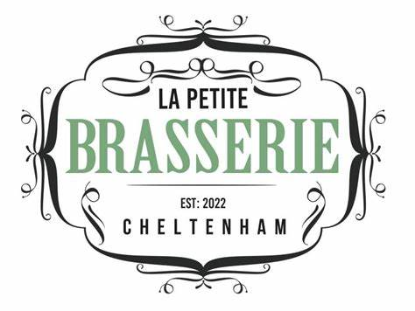

**KIDS MENU**

Grilled vegetable board with hummus £5

Chicken Macaroni & cheese with fries £7

Chicken goujons with fries £8

Penni Pasta bolognaises £8